Data Technician Workbook
Week 1: Excel

Name:
Course Date:
Table of contents
Day 1: Task 1 2
Day 2: Task 1 2
Day 2: Task 2 3
Day 2: Task 3 4
Day 3: Task 1 4
Day 3: Task 2 5
Dataset: 5
Step 1: Create a Pivot Table 5
Step 2: Use the SWITCH Function 5
Submission: 6
Day 3: Task 3 6
Day 4: Task 1 7
Course Notes 9
Additional Information 10

Day 1: Task 1

Please research and complete the boxes below on common laws and regulations that must be followed when working with customers' data, and use the below bulleted list to support your answers.

- What is it
- Why is it important
- Provide a real-world example of how you can follow it
- How does it impact working with data
- What could happen if you breached it

Data Protection Act | The data protection act is an act for the regulation of the processing of data of an individual (legislation.gov.uk). This act ensures individuals have the right to privacy of their personal data from any other individual without their consent. As an employer taking on an employee, the employer requires the consent of the employee to handle their data, as well as, to protect their data from outside threats. Therefore, stringent protocols must be followed when handling personal data of individuals. Such as, password protecting or encrypting files containing such information. For breaches of the Data Protection Act up to £8.7 million or 2% of total turnover of the business can be given as fines for any breaches (ico.org.uk).
GDPR | GDPR is described as any type of data that can be used either directly or indirectly to personally identify an individual (Goddard, 2017). It is important as it ensures that obtainees of such pieces of data highlight strong transparency and openness as well as explicit and clear consent of the individual (Goddard, 2017). This impacts working with data as it holds businesses accountable to ensure that civilians data is held with confidentiality as the number one priority. This can be done by storing personal data in files with encryptions or storing physical, written data in locked cabinets that only authorised managers have access to. For severe violations of GDPR up to 20 million Euros fine can be applied to a business, or 4% of their total global turnover (gdpr-info.eu).
Freedom of Information Act | The Freedom of Information Act of 2000 entails that any individual has the right to make a request to a public authority has any information that has been described and whether it holds that that information, if so to communicate that information to the individual (legislation.gov.uk). This is important as this allows citizens to hold officials accountable for decisions that they make. Therefore, they have to be transparent about the decisions they make and limits the level of power they can wield. Anyone found guilty of interrupting the acquisition of said information can be find up to £5,000 and will be charged with a criminal offence and obtain a criminal record (legislation.gov).

Day 2: Task 1

Please research and complete the following tasks within the retail-sales_dataset.xlsx document, and paste a print screen into the provided boxes below:

- In the sheet ‘retail_sales_dataset’, add all available data between columns A – H into a ‘table’ using Ctrl+T. Then name the table.
- Using the ‘filter’ function, filter ‘Age’ from ‘largest to smallest’
- Using the ‘SUM’ function, show me the commission total in cell ‘P10’
- Using the ‘AVERAGE’ function, show me the average commission in cell ‘P11’

Print screen 1 | 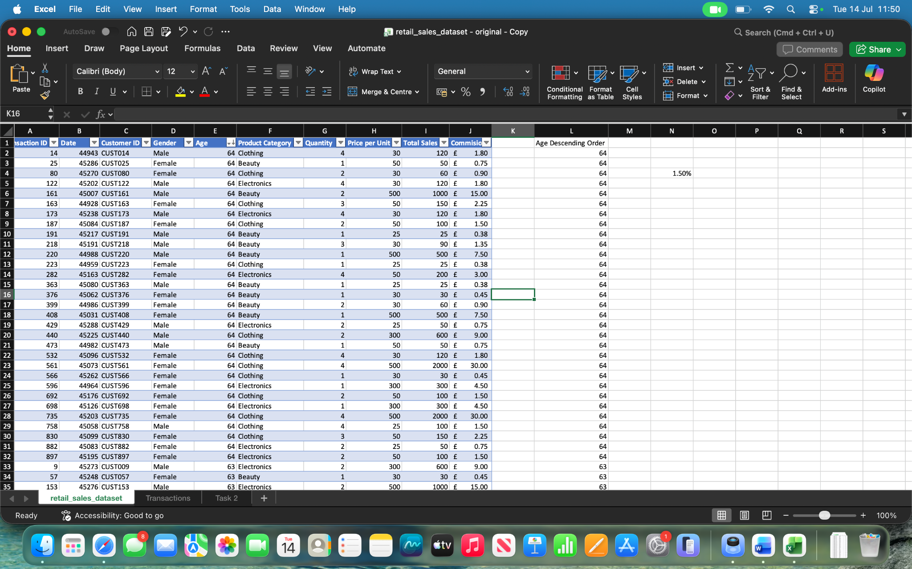
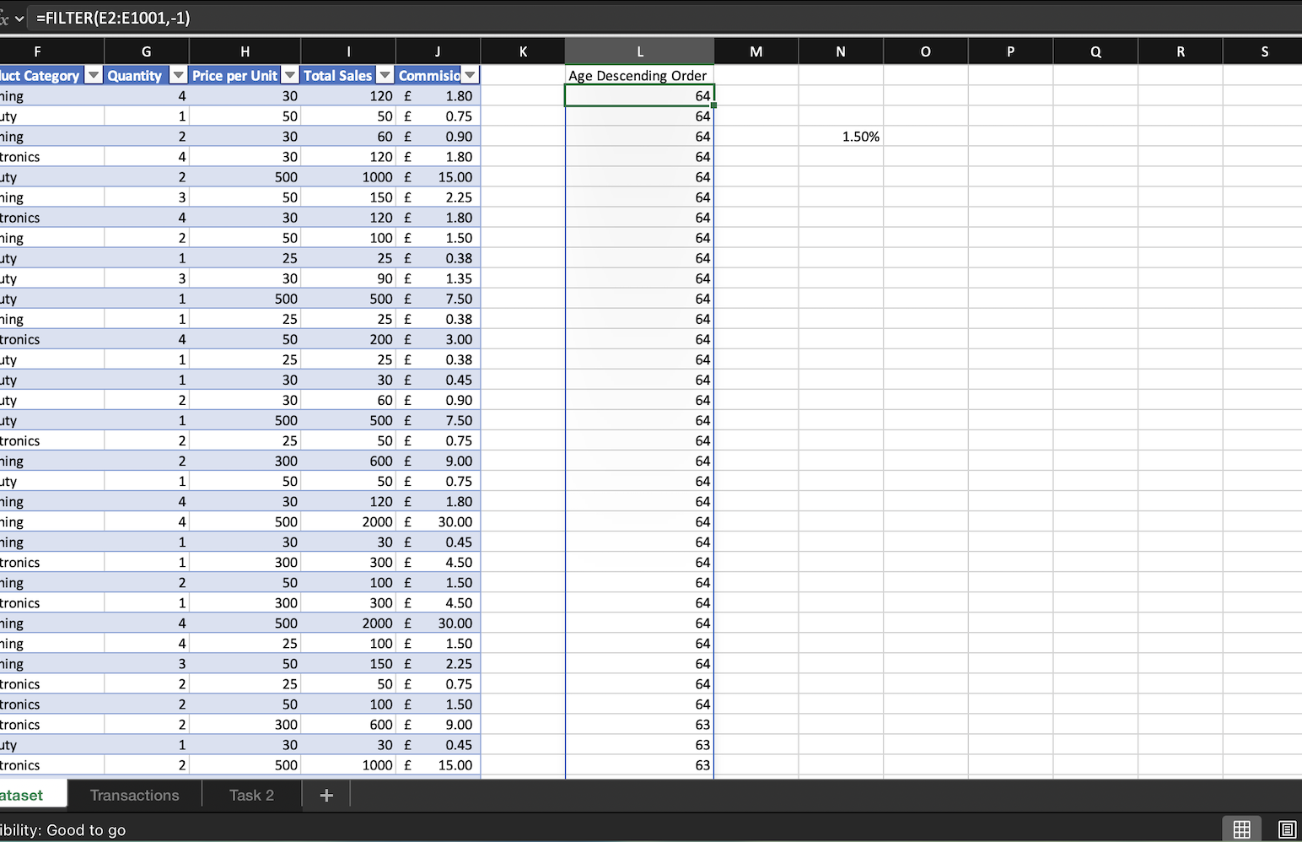
Print screen 2
Print screen 3 | 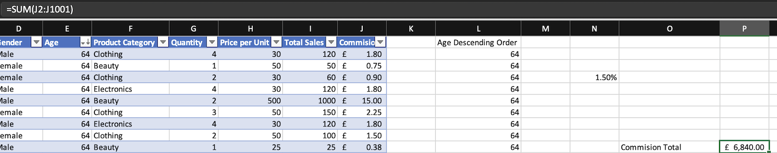
Print screen 4 | 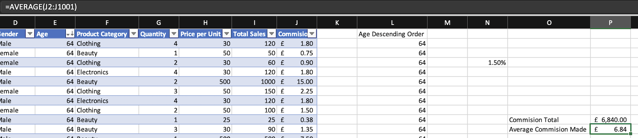

Day 2: Task 2

Please research and complete the following tasks within the document, and paste print screens into the provided box below:

Use the Student grades table provided by the tutor,

Convert the table to an Excel table. (Ctrl +T)

Student name | English | Mathematics | Science | Average | Highest score
Carol | 75 | 85 | 85
Khan | 85 | 75 | 80
Harry | 80 | 70 | 80
Sarah | 80 | 70 | 80
John | 65 | 80 | 70
Linda | 90 | 50 | 70
Edward | 55 | 80 | 60
Mary | 55 | 70 | 65
Thomas | 55 | 30 | 65

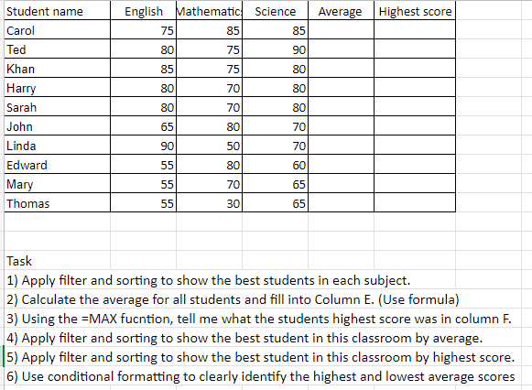

Print screen 1 | 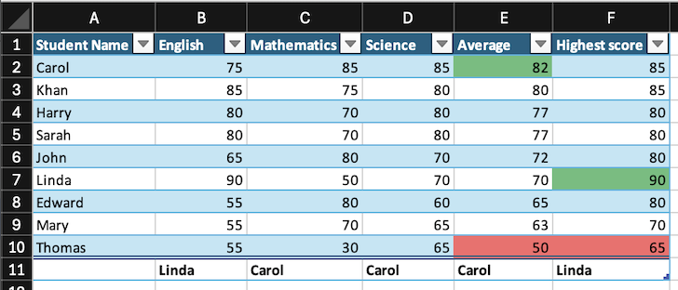

Day 2: Task 3

Using the skills developed today, have some fun with the data set you have imported. Paste your work below and enjoy!

Print screen 1 | 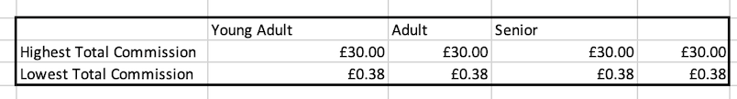  SS1: This table highlights the filtering for the highest and lowest commissions achieved for each age group defined as: Young Adult, Adult and Senior.  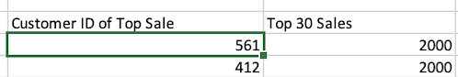  SS2: Highlighted in screen shot 2 I have captured the top 30 sales using the =LARGE function in my Total Sales column. I have then used the =INDEX function to identify which of those top 30 sales are attributed to those specific Customer ID’s. Shown in the SS Customer ID’s 561 and 412 both scored 2000 in sales.

Day 3: Task 1

Dataset: Day_3_Task_1_Bike_Sales_Pivot_Lab.xlsx. and,
Lab instructions: Lab pivot table use for task 1 instructions

Make a copy of the dataset. Use the copy.

Convert to Excel Table (Ctrl +T)

Follow the lab instructions. Do not worry if you do not complete the lab; just working with data and playing with the pivot table will be a good experience.

Note:
Under refine the pivot table:
To mask 0's.
Click the pivot table
Click the Pivot Table Analyse tab on the menu bar.
Options > options > layout and format> In the field for empty cells, select the checkbox and enter 0 (zero). Ok.

And for the reflection questions, please do them in your workbook, not in the lab. 😊

Please paste your final pivot table below and complete the reflection questions:

Print screen 1 | 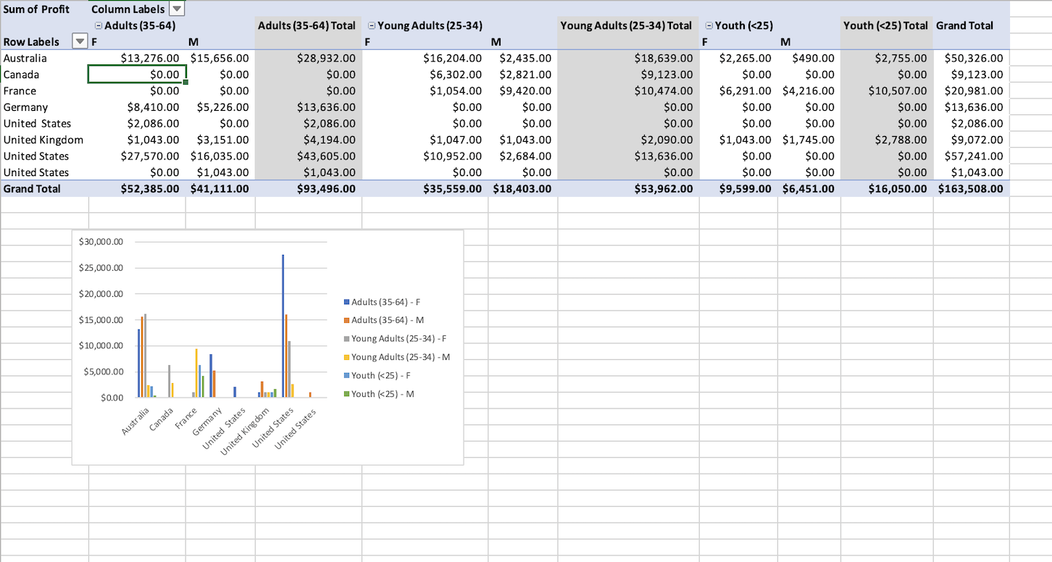
In which markets does Germany have customers? | Adults 35-64 Female, Adults 35-64 Male.
What country has sales in all markets? | The United Kingdom and Australia has Sales in all Age Groups and in both genders.
What are the most profitable markets by country, age group, and gender? | The most profitable market by country is the United States $57,241. The most profitable market by age group was Adults $93,496. The most profitable market by gender was Female $97,543.
Any other findings? | 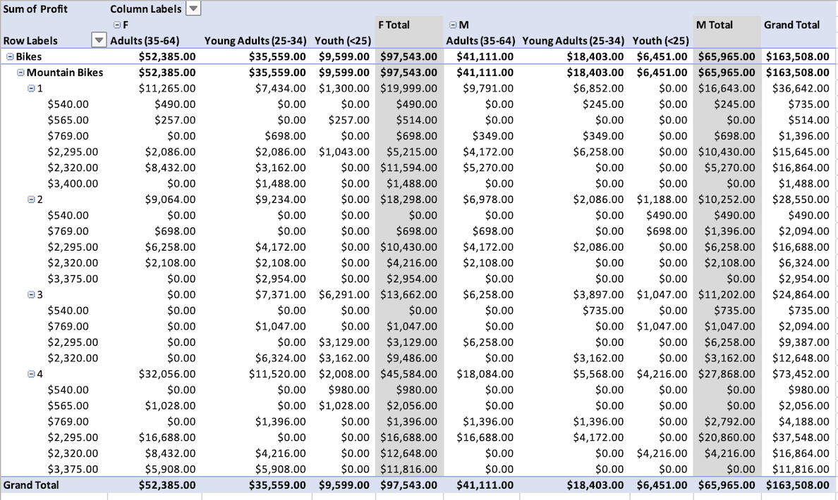  Expanded to include Unit Cost and Unit Quantity. This has opened up the table to look and feel like an order transaction form which business could use to ensure to correct number of stock has been inputted onto its system.

Day 3: Task 2

The dataset below tracks the sales performance of different products in various counties in England. Please paste the dataset into a blank Excel workbook. Your task is to:
- Create a Pivot Table to summarise the data by county and product.
- Use the SWITCH function to categorise products based on their sales volume.
See instructions below.

The dataset can be found in the last workbook you used.

County | Product | Sales Volume
Yorkshire | Laptops | 500
Yorkshire | Smartphones | 200
Cornwall | Laptops | 700
Cornwall | Printers | 400
Lancashire | Smartphones | 150
Lancashire | Laptops | 600
Essex | Printers | 800
Essex | Smartphones | 300
Durham | Laptops | 250
Durham | Printers | 300
Greater Manchester | Smartphones | 600
Greater Manchester | Laptops | 400

Dataset:

Step 1: Create a Pivot Table
- Select the dataset (columns A to C).
- Insert a Pivot Table to summarise the data by County in the rows and Products in the columns. Use Sales Volume as the value to be summarised.

Step 2: Use the SWITCH Function
In a new column next to your data, use the SWITCH function to categorise products based on Sales Volume as follows:
For sales greater than 600: "High"
For sales between 300 and 600: "Medium"
For sales less than 300: "Low"

SWITCH Function Example:
=SWITCH(TRUE, C2 > 600, "High", C2 >= 300, "Medium", "Low")

- Apply this formula to each row, and check if the products are categorised correctly.
- In ‘Sales Volume’, you need to remove the space after each amount – hidden spaces
- Confirm the data type is numerical

Submission:
- A completed Pivot Table summarising sales by county and product.
- A new column in the dataset categorising products by sales volume using the SWITCH function.
  - Please paste your completed work below

Print screen 1 | 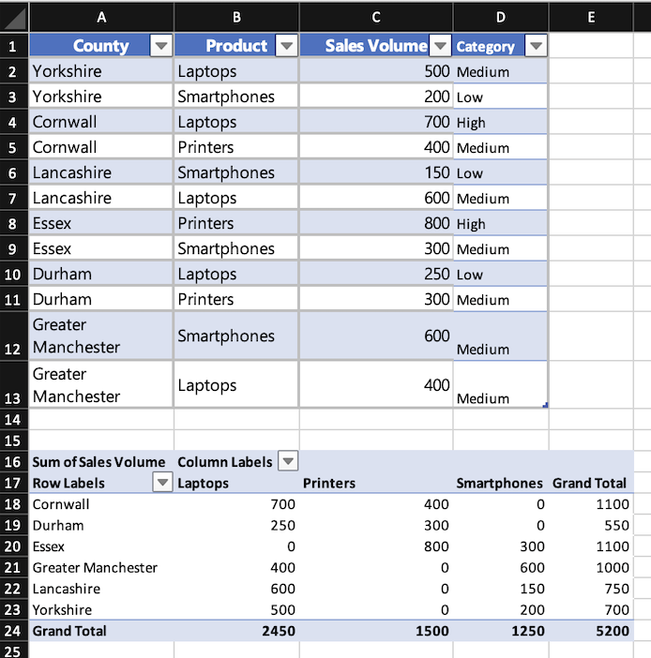

Day 3: Task 3

Please download the dataset ‘Day_3_Task_3_Bike_Sales_Visualisations_Lab.xlsx’.
Also, download the lab instructions.

Pivot tables are already created; you will need to create the pivot charts.

Follow the lab instructions.

Do not worry if you do not complete the lab; just working with data and playing with the charts will be a good experience.

Please paste your results below:

Print screen 1 | 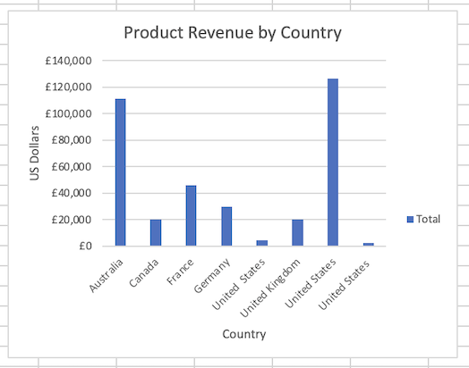  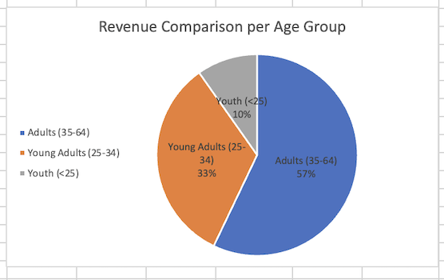

Day 4: Task 1

You have been asked to deliver your analysis findings to the board of directors. Within your analysis, you have identified that customers are leaving your company at the 12-month point, which is typically when they receive their renewal price.

Choose a business or organisation to focus your findings on.

Conduct research and complete the following questions:

As in all work situations, you can use AI Gen tools for research: it needs to be in British English, check spelling, grammar and maths; and written in your voice, not copied directly from the tool.

How would you prepare for the delivery? | Minimum one meaningful paragraph, and no more than three, is all that is required.  Why are people leaving Sky Broadband?  I would perform some market research to compare competitor prices against sky broadband.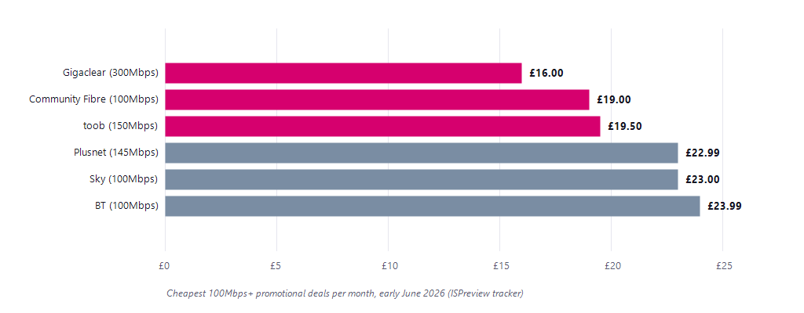  (BroadbandSwitch.uk)  I would also look into some of the biggest cons into staying past the 12-month point in the company. Typically, this may come with a contract renewal. (Uswitch.com) explains that in 2026 Sky broadband prices have risen £3 regardless of whether you are mid-contract or at the end of contract. Furthermore, as this is no longer a percentage increase this is punishing customers on a lower tariff more which when paying for broadband is typically a lower end industry. (Sky Promotion Deal = £23.00 per month - see above, a 13% increase). After finding evidence of financial reasons for customers to not to renew I would also need evidence of other potential factors that would influence this drop in retention. https://www.uswitch.com/broadband/reviews/sky/  Sky Broadband was rated (3.81 Average out of 5) for value for money as well as (3.86 Average out of 5) for customer service. In addition to this, Uswitch labels that cons given to Sky Broadband from customer feedback as “not the cheapest” and “not the fastest”. This should raise concern as Sky Broadband are known to be a market leader so while they may be considered expensive that expense should not at the expense of the quality of the service. Some customers would be able to overlook the price point as long as the high level of broadband speed was there.
What tools would you use for the delivery? | Microsoft Word - I would use Microsoft Word to mind map some potential pros and cons that customers would consider between switching to a new company and the cons of staying at Sky. I would also use Microsoft Word to evaluate some customer feedback surveys to give understanding and reasoning on their qualitative information.  Microsoft Excel - I would look into some competitors financial figures such as Virgin Media for example and look into the lowest offer they would give on price comparison sites and then use a WHATIF function to see how low would Sky’s Prices have to be to equal the lowest offers from competitors.  PowerPoint - To create the presentation and present my finding such as graphs, charts.
What is prospecting, and why would you complete this before your delivery? | Prospecting includes processes such as cold calling, direct mail, or connecting through Linked In (Linkedin.com).(D’Haen & Van Den Poel, 2013) states that retaining a customer is much more affordable than spending on customer acquisition. Therefore, following adequate prospecting processes before my delivery would ensure that I have done as best as I could to retain as much of the company's budget as possible.
Tell me the best practices for public speaking and providing updates to senior leaders | The best practices for public speaking are; firstly, having a good knowledge of the information of which you will be presenting because if you do not then you will end up breaking up pauses or silences anxious sounds or ”um’s” which don’t sound professional and can infer that you may not be too knowledgeable on the information you are presenting.  Secondly, senior leaders most importantly would want the information that will affect the business. Therefore, succinct and effective bullet points of your information as opposed to retaining whole sentences of information allows that to be conveyed in a more digestible way that’s easier to understand and more legible to get across to a different party. This in turn, can be broken up by visuals that senior leaders would be able to look at with conditional formatting that makes it clear and obvious whether the data they’re being shown is positive or negative.
What will you show the board in your delivery? | In my presentation, I would present in particular time-series graphs that highlight when the financial quarter comes to an end on 12 month contracts there is a drop in contract renewals in the company. Highlighting to the senior leadership team that this is an issue that needs to be addressed. Visuals will also be provided of renewals made through automatic renewals or prospecting techniques. This will be done to highlight whether this has been done to high effect or more work needs to be done on these areas to improve customer retention.  We can also potentially show to the senior leadership team some qualitative analysis through surveys and feedback from consumers to get a consensus on why they are not choosing to stick with the company. Whether this is through, receiving better offers from the competition such as Virgin Media, or our renewal rates being too high.
How will you articulate the changes that are needed? | As previously stated, customer acquisition is more costly to the business than customer retention. Therefore, a potential review into the pricing on contract renewal my provide some insight into potential avenues into which direction to go. An advantage of using more retention oriented strategies is that customers are more likely to stay committed to one company if they feel like they are being correctly compensated. This may be due to the extra fuss of having to find a competitor and discussing a deal with them.
Provide a list of online resources and videos that will support your preparation for public speaking | https://youtu.be/wTE87rlaLiY?si=V9ggIDC3UZh380jC  https://youtu.be/w7zSgY50bKg?si=r7qRvJDbYYY7gSvp PhD: How to present a poster at an international conference
Evaluate tools that provide visualisation.  Tell me what they are.  Tell me what you would choose when delivering your presentation and why | A mix of Pivot tables with accompanying Sliders will be used as this will allow for dynamic changes throughout a presentation if senior leaders need a different parameter looking into.

Course Notes

It is recommended to take notes from the course, use the space below to do so.

Additional Information

We have included a range of additional links to further resources and information that you may find useful, these can be found within your revision guide.

END OF WORKBOOK

Please check through your work thoroughly before submitting and update the table of contents if required.

Please send your completed work booklet to your trainer.

